A
Report

On

Students’ Seminar
Session- 2019-20

Department of Philosophy
Rabindra Mahavidyalaya, Champadanga

Theme:
Values in Indian Philosophy & Culture
Venue: Department of Philosophy
Date: March 06, 2020
Organizer: Department of Philosophy
Paper Presenters: Students of Semester IV & VI (Hons.)
Audience: Students of Semester II, IV and VI (Hons.)
Objectives
- Learn a systematic study of ideas and issues;
- Pursuit of fundamental truths, a quest for a comprehensive understanding of the world, a study of principles of conduct and much more.
• Development of Discussion skills, exhibit independence and flexibility of thought, and time management;
- Stimulate listening skills, argumentative skills and critical thinking;

Proceedings
The seminar, hosted by Prof. Soumitra Das, began with the introductory speech given by Prof. Hasina Sikdar, Assistant Professor of Department of Philosophy of the institution. All three technical sessions were chaired by the departmental faculties. Prof. Soumitra Das and Prof. Sima Choudhury acted as judges. Prof. SuklaSaha monitored the whole session. There were three groups of paper presenters, each group containing not less than three students. All sessions were very interactive where pupils have been quite enthusiastic, and all of their questions have been satisfactorily answered. 34 students (Male: 10, Female: 24) participated in the seminar. The seminar ended with vote of thanks by Prof. Hasina Sikdar.
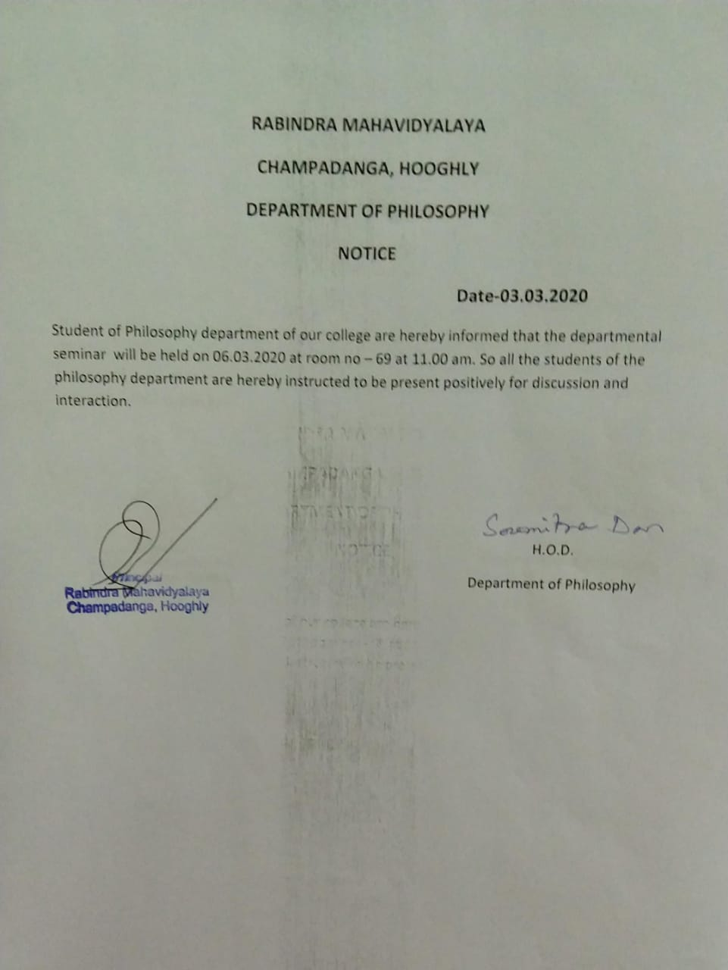

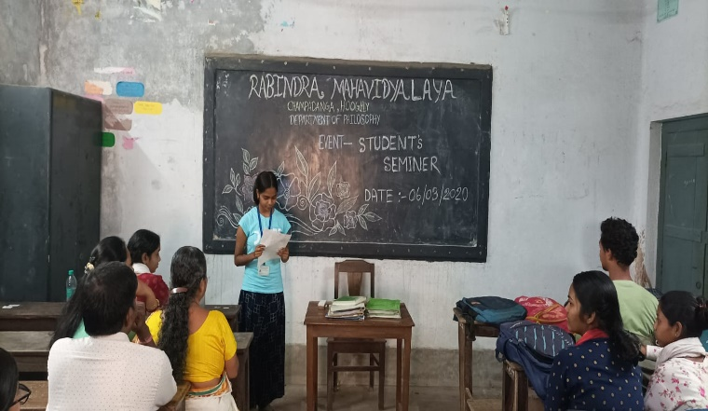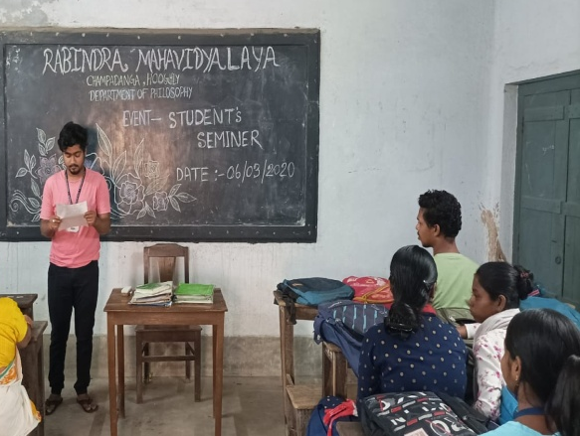
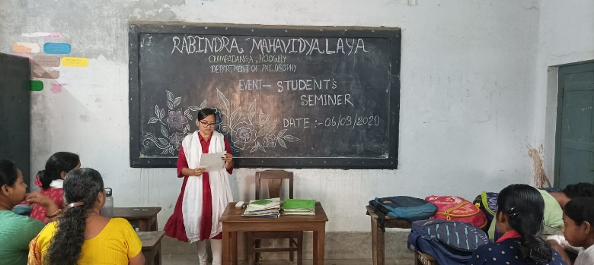
Paper preseted by students
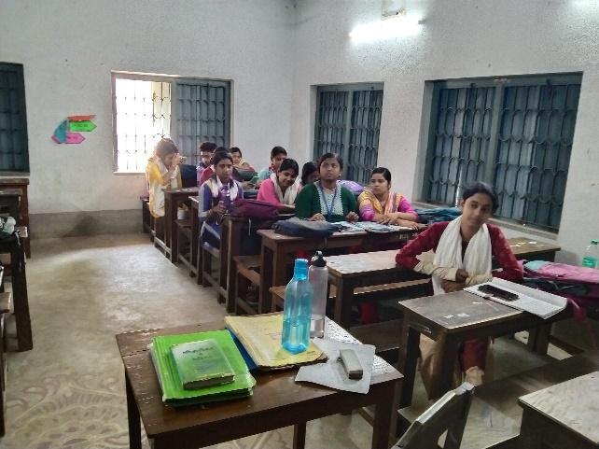
Our students

Student’s Seminar
Theme: Vlues in Indian Philosophy & Culture
Date: 06.03.2020
Venue: Department of Philosophy, Rabindra Mahavidyalaya, Champadanga
Time: 12 noon to 3 p.m.

- Inauguration
- Principal’s Speech
- Technical Session 1: 12.30 p.m. to 1.15 p.m.

- Chairman: Hasina Sikdar
- Rapporteur: SuklaSaha
- Paper: Values in Veda & Upanishad
- Lunch Break

- Technical Session 2: 1.30 p.m. to 2.15 p.m.

- Chairman: Soumitra Das
- Rapporteur: Sima Choudhury
- Paper: Values in Buddhism

- Technical Session 3: 2.20 p.m. to 3.05 p.m.

- Chairman: SuklaSaha
- Rapporteur: Soumitra Das
- Paper: Values of society in ancient Indian culture

- Prize Distribution
- Vote of Thanks: Prof. Hasina Sikdar

Student’s Seminar

List of Participants

Theme: Concept of Moksha in Indian Philosophy
Date: 06.03.2020
Venue: Department of Philosophy, Rabindra Mahavidyalaya, Champadanga
Time: 12 noon to 3 p.m.

- Paper: Values in Veda & Upanishad

- Presenters: Priyanka Manna, Swapna Adak, Sreyasi Manna &MousumiHazra.

- Paper: Values in Buddhism

- Presenters: Riya Samanta, RitamSaha, Anamika Manna &Bidisha Dey.

- Paper: Values of society in ancient Indian culture

- Presenters: Arpita Adhikari, Kush Samanta, Shampa Dey & Anamika Roy.

Feedback Summary
- 48 responses (75%) received.
- 82% felt satisfactory.
- 90% opined the event helped to improve their academic performance.
- 75% wished to occur the events more than once every year.

What have students learnt from the event?
- Presentation skills;
- Self-confidence;
- Critical thinking;

Suggestions
- More extra-curricular activities and healthy competition;
- Special class for grooming;

